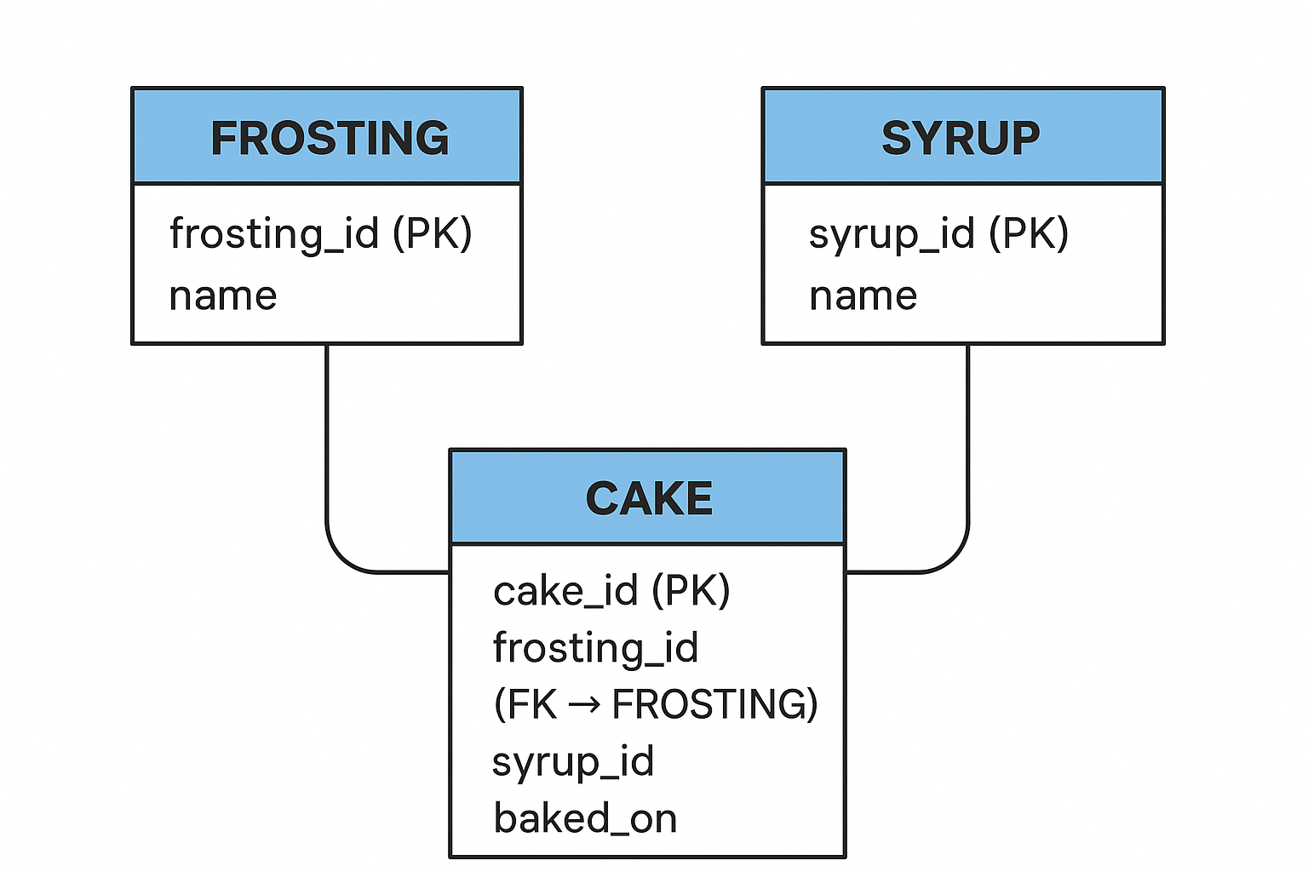

Entities:

1. FROSTING
- frosting_id (PK)
- name

2. SYRUP
- syrup_id (PK)
- name

3. CAKE
- cake_id (PK)
- frosting_id (FK → FROSTING)
- syrup_id (FK → SYRUP)
- baked_on

🔗 Relationships:
- Each Cake has exactly one Frosting
→ (1 Frosting : Many Cakes)
- Each Cake has exactly one Syrup
→ (1 Syrup : Many Cakes)
This forms a Many-to-One relationship from CAKE → FROSTING
and Many-to-One from CAKE → SYRUP.

